Building a Nation
Chapter 2 Study Guide
Socials Studies 10 - Mr. Morrison

Table of Contents
The Idea of Confederation....................................................... 2
Economic problems in the BNA................................................2
The Colonies of BNA finally get responsible government........4

The Advantages of Confederation...........................................5
Economic Advantages..............................................................5
Military Advantages.................................................................6
Political Advantages.................................................................7

Confederation Achieved..........................................................9
The BNA Act...........................................................................11

The Idea of Confederation
1. This chapter is about the creation of Canada. Some of the BNA colonies were in favour of it, while others were not. The following is a list of colonies who would consider uniting to form the nation we know as Canada. Record in the boxes below: 1.Whether each colony supported or rejected the idea of Confederation, and 2. Their reason for supporting or rejecting the idea. (p.73)
COLONY | SUPPORT/REJECT | REASON
Canada West
Canada East
Maritime colonies

Economic Problems in the BNA
2. On both sides of the Atlantic (ie. BNA and Britain), many people feared that giving the colonies responsible government, and letting BNA govern themselves without Britain's interference, could create economic problems both in Canada and Britain. The economies of BNA and Britain were linked closely together. Explain the economic connection between the two colonies. (p. 73-74)

3. Define how mercantilism works. (p. 74)

4. Draw an illustration to show how the economic policy of mercantilism worked. (p. 74)

5. Until the 1840s, the economic policy of mercantilism linked Britain and the BNA's economies. However, by the 1840s, Britain's economic relationship with the colonies was changing because Britain was no longer making a lot of money under mercantilism, and they were now looking for a new economic policy. To begin with, Britain cancelled their Corn Laws. What were these Corn Laws? Also, why would Britain cancelling their Corn Laws be a problem for the economies of the United Canadas? (p. 74)

6. What economic policy did Britain replace mercantilism with? Instead of buying grain, wheat and flour from the Canadas, Britain would be buying these products from some other nations or colonies. Explain. (p. 74)

7. After Britain cancelled their Corn Laws, Canada and all of the BNA colonies went into a depression. What does this mean when a country goes into an economic depression? (p. 74)

8. Why did the colonies of BNA go into an economic depression when Britain cancelled their Corn Laws? (p. 74)

9. Why did this economic depression help Canadian politicians successfully sell their ideas for Confederation? (p. 74)

The Colonies of BNA Finally Get Responsible Government
Remember Lord Durham's recommendations to give the colonies in BNA responsible government? This recommendation was not acted upon immediately because resistance was strong in both England and the Canadas, especially among the supporters and members of the Family Compact and Chateau Clique. However, this resistance only existed because of the closely linked economies of Britain and the BNA colonies. They believed that responsible government would threaten the economic policy of mercantilism. By the late 1840s, however, the policy of mercantilism had been dropped and replaced with a new policy of free-trade. So, as the economic connection with the colonies was severed, the British government became less interested in the colonies and were thus ready to grant the colonies responsible government.
10. After Lord Durham left the BNA, the governor who replaced him, Lord Charles Bagot, did not support the idea of self-government. Explain. (p. 74)

11. When did Britain finally decide to support Durham's recommendations and give the colonies responsible government? (p. 74)

12. Who did Britain appoint as Canada's new governor in 1847 - the man who would put responsible government into operation? (p. 74)

13. How did responsible government change the economic relationship between Britain and the colonies? (p. 75)

14. How was this new economic relationship between Britain and the colonies an advantage for Britain? (p. 75)

15. Responsible government meant that any law passed by the legislative assembly could no longer be vetoed by the appointed executive and legislative councils. The first test that would prove to Canadian citizens that they really had responsible government came in 1849. What law was passed in 1849 that the Governor, Lord Elgin, would have preferred to veto, but could not? (p. 75)
16. Describe what is happening in the picture below. What is burning? Who burned it? Why was it burned? (p. 75)
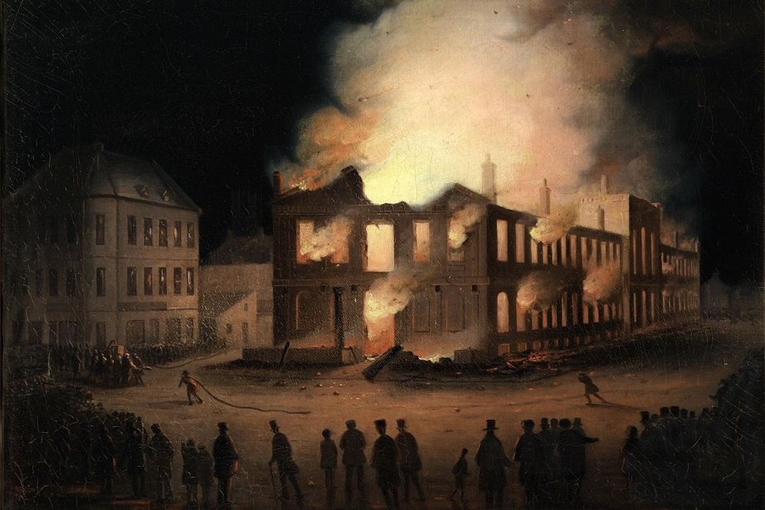

17. Why did Lord Elgin sign the Rebellion Losses Bill when he really did not want to? (p. 75)

The Advantages of Confederation
The concept of Confederation started at the top. Those at the top had to sell their vision to the skeptics and win over the politicians and business people who regarded Confederation as a bad idea with some fancy political manoeuvring, persuasion, and debate. Their strategy was the show that Confederation was the answer to solving all of their economic, military, and political problems.
Economic Advantages
Questions 2-9 outlined the economic problems the BNA colonies were facing after Britain cancelled their Corn Laws and ended their policy of mercantilism. The Canadas temporarily fixed this problem by entering into a privileged trading relationship with the United States, which was contained in the Reciprocity Treaty of 1854. The Reciprocity Treaty allowed BNA's natural resources to enter the US tax-free. This solution, unfortunately, was short-lived. The US cancelled the treaty twelve years later in 1866, and the BNA economies were in trouble yet again. Confederation could solve these problems in a series of ways...
18. Explain the argument the supporters of Confederation used to convince the skeptics of Confederation that a union of the BNA would bring economic stability and prosperity to their economies. (p. 76)

19. If the skeptics chose to support Confederation, the new nation that would be created would have a strong central government. How would a strong central government of their new nation be able to further help out the economies of the BNA? (p. 76)

20. Why would the colonies need to join Confederation to build a railroad? Why couldn't they do this the way things were right now - as separate colonies? (p. 76)

21. How would linking the United Canada's to the Maritime colonies further help improve Canada West and East's economies? (p. 76)

Military Advantages
Military problems in BNA
22. The same railway that a centralized Canadian government would build to link the colonies for trade purposes would also link the colonies for defensive purposes. Why would the colonies need to worry about defending Canada now when they never had to worry about it before? (p. 76 - Also ask Mr. Morrison for assistance)

23. What military threat existed in the Prairie Region (or West) of the BNA? (p. 76)

24. What does "to annex" mean? (p. 76)

25. Why would Canadians be so suspicious of US intentions to annex the west? (p. 76)

26. Some American politicians were making election campaign speeches about "Manifest Destiny." What is Manifest Destiny, and why would Canadians take Manifest Destiny seriously? (p. 76)

27. What was one military disadvantage that the BNA had as long as they remained individual colonies? (p. 76)

28. Another far more serious threat dealt with the American Civil War. How did the Civil War heighten the American military threat to the BNA? (p. 76)

29. Go to page 83 to answer this question. Most skeptics of Confederation did not take the military advantages of Confederation seriously until a new military threat - The Fenian Raids - surfaced in 1866. Explain this new military threat to the BNA, and why it pushed the skeptics to believe in the military advantages of Confederation.

30. How would Confederation solve all of these military problems? (p. 76)

Political Advantages
31. The government of united Canadas was not very efficient, and did not have a structure like the governments of today - they lacked internal organization. How do modern governments maintain internal organization? (p. 77)

32. The governments of the BNA were filled with "loose fish." Why were these "loose fish" a problem? (p. 77)

33. What additional problem with BNA governments often created political crises? (p. 77)

34. In the United Canadas, what did politicians in the Canadas have to do to keep power in their colonial government? (p. 78)

35. Coalition governments often left the politicians in Canada frustrated. Why? (p. 77)

36. The four political parties in the table below had to keep building coalitions in order to govern. Once you have completed the table, you will be able to see why running a coalition government was so frustrating because of the differing policies and support bases these parties had -- in order to pass legislation, the parties would have to agree on forming a coalition and compromising with one another. However, every time these coalitions tried to pass a law and failed, a new election had to be held, and thus a new coalition government was formed. Fill in the missing information in the table below. (p. 78)
Part of Canada | Political Party | Party Leader | Party Policies | Party's Support Base
Canada West  (English) | Conservatives  (Tories)
Canada West (English) | Clear Grits
Canada East (French) | Parti Rouge
Canada East (French) | Parti Bleu
37. What is Representation By Population ("Rep by Pop")? (p. 78)

38. Who supported "rep by pop" and who opposed it. Why? (p. 78)

39. Aside from the need for coalition governments, there was another barrier to good government in Canada. Explain what this barrier was, and why it was a barrier to good government. (p. 79)

40. What divisions existed in the united Canadas that were insurmountable for the government of the Canadas? (p. 79)

41. How would Confederation solve the political problems of the BNA? (p. 79)

Confederation Achieved
The Confederation Conferences (p. 82-84)
42. What was The Great Coalition?

43. Who made up The Great Coalition?

44. Why was The Great Coalition set up -- what was its purpose?

The Three Confederation Conferences
The First Conference
45. Where and when did the first Confederation Conference take place?

46. Explain why this conference was originally set up.

47. Which BNA colonies attended the conference?

48. What was the result after the first conference ended?

The Second Conference
49. Where and when did the second conference take place?

50. What happened at the second conference?

51. Which colony was at this conference that was not at the first?

52. Because the colonies now had responsible government, the delegates themselves could not simply meet and decide whether Confederation would happen. Explain.

53. How did the elected legislative assemblies in each of the colonies vote on Confederation?

The Time between the Second and Third Conferences
54. What particular parts of the Confederation proposals were greeted with opposition?

55. Before 1866, none of the colonial legislatures agreed to Confederation. What were the two factors (1 economic, 1 military) that caused them to change their minds? (go to page 82 in the first column of the text, and page 83, Figure 2-28 to find the answers)

The Third and Final Conference
56. Where and when did the third conference take place? (p. 84)

57. Which colonies attended this third conference? (p. 84)

58. Which colonies were at the second conference but not at this one. Why did they not attend? (p. 82)

59. What was the purpose of this third conference? (p. 84)

The BNA Act
60. What was the BNA Act? (p. 85)

61. The BNA act was Canada's constitution until 1982 when it was replaced by the Canada Act. What is a constitution? (p. 85)

62. The BNA says what things the provincial and federal governments will have control over. Look up the responsibilities on pages 86 and 87 and record what levels of government (ie. federal or provincial) is responsible for each.
e. Hospitals_________________________________
f. Taxes_____________________________________
g. Regulation of trade and commerce____________
a. Postal Service_________________
b. Education____________________
c. Currency______________________
d. Military Defence_______________

