The Northwest to 1870
Chapter 4 Study Guide
Socials Studies 10 - Mr. Morrison

Table of Contents
The Hudson's Bay Company.....................2

The Northwest Company.........................3

The Native Peoples of the Northwest......4

The Northwest from 1800 to 1860...........5

The Colony on the Red River....................6

The Merger of the HBC and NWC............7

The Red River Settlement 1821 to 1860...8

Changes: The Red River Settlement From 1860 to 1870............................................9

Canada Buys Rupert's Land......................9

The Red River Rebellion.........................10

Introduction
In the early years of the 19th century (the 1800s), the Northwest was known only to the Native Peoples, the Metis, and fur traders. This study guide focuses on the heartland area of the fur trade (Rupert's Land), and follow its development up to 1870 when the province of Manitoba was created. Part 1 of this study guide will look at fur trade in the Northwest, and Part 2 will look at the people and events responsible for the creation of Manitoba.

The Hudson's Bay Company (HBC)
1. What year was the HBC created? _________ (p.130)
2. Who was controlling the fur trade in the Northwest at this time? _______________________(p. 130)
3. The King of England, Charles II, did something very important for the HBC. What was this? (p. 130)

4. The land given to the HBC was called ______________________________, and you would know this land was included in the territory because _________________________________________________ ____________________________________________________________________________________.
HBC Trading Strategy
5. Why did the HBC only build their trading posts at the mouths of rivers emptying into the Hudson Bay -- why did the HBC not just build trading posts inland from the Hudson Bay? (p. 130)

6. What was this trading strategy called? _____________________________________________(p. 131)
7. What would the native people in the Northwest have to do if they wanted to trade their furs to the HBC? (p. 131)

HBC Trading Standards/Practices
8. What was the HBC's trading standard around the price of trade goods? (p. 131)

9. What was the HBC's policy regarding alcohol as a trade item? (p. 133)

HBC Company Structure
10. The HBC Company Structure was set up as a hierarchy. Draw a picture of what the HBC hierarchy looked like. (p. 131)

Getting furs out and goods in
11. Where did the HBC furs go and the HBC trade goods come from? ______________________(p. 131)
12. The time available for the HBC to ship furs out and bring trade goods in is limited. Explain. (p. 131)

The North West Company (NWC)
13. What year was the NWC created?______________ (p. 132)
14. How did this fur trade company get created? (p. 132)

15. How did this new fur trade company affect the "Stay by the Bay" strategy of the HBC? (p. 132)

16. What did the HBC have to do to win back some of the trade that had gone to the NWC? (p. 132)

NWC Trading Strategy
17. Unlike the HBC, the NWC built their trading posts inland. What was the geographic reason behind this strategy? (p. 132)

18. Why would trading at inland NWC posts be better for Native peoples than trading with HBC posts on the shores of Hudson's Bay? (p. 132)

19. Why did the NWC establish a major trade depot at Fort Williams, at the head of Lake Superior? What was the fort's role in getting furs out and trade goods in? (p. 132)

NWC Company Structure
20. The structure of the NWC was a partnership, which was divided into two categories. What were these categories, and what was the role of each? (p. 133)

21. Who were the voyageurs? What was their role in the fur trade? (p. 133)

22. Why did the NWC partners hire explorers? (p. 133)

23. How far did the network of NWC trading posts stretch? (p. 133)

The Native Peoples of the Northwest
24. Before European contact, the Northwest was home to four aboriginal nations. What were they? (p. 135)

25. What was happening with these aboriginal nations as the fur trade moved west? (p. 136)

26. Many Native peoples became so involved with the fur trade that it disrupted their way of life. Explain. (p. 136)

27. Contact with the Europeans also exposed the Native peoples to ___________________ (p. 136). The Native people were hit harder by this than Europeans because _____________________________
____________________________________________________________________________________.
The Northwest from 1800 to 1860
Battle for the Fur Trade, 1800 to 1810
28. Competition between the HBC and NWC was fierce. How did this effect the fur bearing animals? (p. 139)

29. How did both the NWC and HBC sharpen their competitive edge in the fur trade? (p.139)

The Metis
30. As NWC traders pushed deeper into the Northwest in the 18th century, they began staying with local groups of Native peoples. As had occurred during the earliest years of the fur trade, a number of fur traders married the daughters of Native families. By 1800, this had led to the emergence of a new people - The Metis. Marriage between fur traders and Natives was encouraged by the NWC and the Native peoples. Why is this? (p. 139)

31. There were a sizable number of Metis by the early 19th century, and they were developing a new culture of their own that combined both Native and European customs. Explain. (p. 140)

32. Where were the largest number of Metis living in the Northwest by 1810? (p. 140)

33. The Bison Hunt was one of the most significant events in Metis culture. When did the bison hunt take place? What was the bison used for? Who was involved, and what roles did everyone have? (p.141)

The Colony on the Red River
In 1812, a group of settlers -- named the Selkirk Settlers after their leader Lord Selkirk -- arrived in the Red River Valley, which was the area where the Metis had settled. These settlers were brought to this valley through an arrangement with the HBC, and would have profound implications for the Metis community, the HBC, and the NWC.
34. Where did the Selkirk settlers come from? _________________________________________ (p.143)
35. What had Lord Selkirk deeply troubled about the settlers? (p. 143)

36. What was the deal between Lord Selkirk and the HBC -- how would the HBC benefit from this deal? (p. 143)

37. Why did the HBC feel they had the legal right to make this arrangement without consulting the Metis or the NWC? (p. 143)

The First Selkirk Settlers Arrive in Red River
38. The Selkirk settlers attempted to settle in the Red River on three separate occasions. Explain what happened on each of these occasions. (p. 144)

39. The problems these settlers faced in Red River led their leader, Miles Macdonell, issued the Pemmican Proclamation. What was this proclamation, and how did it affect the Metis and the NWC. (p. 144)

40. What additional action did Macdonell take that caused further problems with the Metis and NWC?( p. 144)
41. The settlers returned once again to the Red River settlement in 1815, and a new governor of the colony arrived with them -- Robert Semple. Semple's actions once governor, however, only invited more between the different peoples living in the Red River settlement. What were these actions, and how did the Metis interpret them? (p. 145)

The Battle of Seven Oaks
In May 1816, a group of Metis, led by a young man named Cuthbert Grant, raided a brigade of HBC boats and seized a supply of pemmican as compensation for the Pemmican Proclamation two years earlier. Grant and his men made their way to the Red River colony a month later. Governor Semple decided that the only way to deal with the Metis -- whom he regarded as inferior -- was with brute force.
42. Describe the confrontation between the Metis and Semple's men. (p. 146)

43. Why was this skirmish, called "The Battle of Seven Oaks", a significant development in the competition between the HBC and NWC? (p. 146)

44. How did Lord Selkirk finally put an end to the many disputes between the HBC and NWC in the Red River Colony? (p. 146)

The Merger of the HBC and NWC
45. Why did the HBC and NWC decide to merge in 1821? (p. 147)

46. What was the name of the new fur trade company? ___________________ (p. 147)
47. What happened to Rupert's Land and the old HBC monopoly after the merger? (p. 147)

48. As a result of the merger, the Native Peoples became even more important to the success of the fur trade operation. Why is this? (p. 148)

49. The HBC also appointed a new head. Who was chosen and why? (p. 149)

50. George Simpson, the new head of the HBC, was given a particular nickname by his employees. What was this nickname, and why was he given it? (p. 149)

The Red River Settlement, 1821 - 1860
51. After 1821, there was peace in the Red River settlement for the next 40 years. Throughout that time, the demographics of the settlement changed dramatically. How was the population of Red River divided according to culture or ethnic origin in 1821 as opposed to 1860? Why was this the case? (p. 150-151)

52. There were three different groups of people in the Red River settlement during this time: Scottish settlers, Metis, and Country-born. How did these three groups typically earn their living? (p. 151)

53. Because the HBC made and enforced the laws in the Red River colony, what was a crime due to the HBC trading monopoly? (p. 152-153)

54. What does the French statement "Le commerce est libre! Vive la liberte!” mean in English, and what significance did it have on the inhabitants of the Red River settlement? (p. 153)

Changes: The Red River Settlement From 1860 to 1870
55. During the 1860s, immigration to the Northwest increased dramatically, Canada became a country, and the HBC started to decline. Why was the Red River valley becoming such an appealing prospect for new settlers instead of Canada West? (p. 155)

56. The new settlers to the area increased tensions in the Red River settlement. Why was that the case for the Metis? (p. 155)

57. One of the most prominent settlers to the Red River valley was Dr. John Schultz. What did Dr. Schultz do for a living, and how did he manage to increase the tensions between the settlers and the Metis? (p. 155-156)

58. What sort of economic problems also contributed to the rise in tensions? (p. 156)

59. By the late 1860s, the HBC was losing interest in the Red River settlement. Why would this be an additional complication for the Metis? (p. 156)

Canada Buys Rupert's Land
60. Why did the HBC sell Rupert's Land to Canada, and why did Canada want to buy it? (p. 156-157)
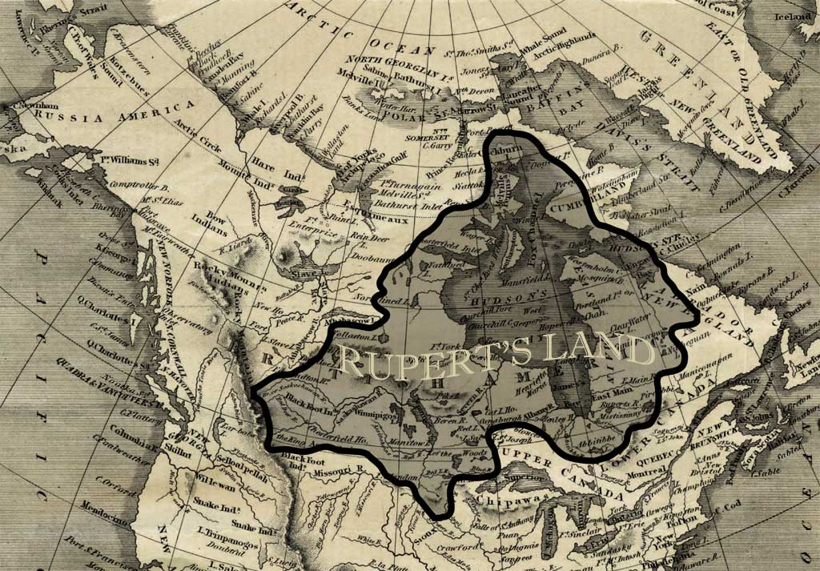

61. What role did the people in the Red River settlement play in this deal, and how did the settlers feel about this purchase? (p. 156-157)

62. What action did the Canadian government take in 1868, before the purchase deal was even finalized? What assumptions were the people acting on behalf of the Canadian government operating on? (p. 157)

The Red River Rebellion
63. When the surveyors arrived, the Metis feared that the Canadian government was trying to take their land away. That summer, a 24-year old Metis named Louis Riel helped to organize bands of Metis to observe and confront the surveyors. This was the beginning of Riel's long and tumultuous relationship with the Canadian government. The following is a list of events that lead up to the include the Red River Rebellion. Read pages 158-162 and place the events into the order that they occurred:
_____
_____
_____

_____
_____

_____
_____

_____
_____

_____
_____
Riel is exiled from Canada, and flees to the United States.
Fearing a civil war between the Metis and the Canadian Party, Riel led a party of Metis to Schultz's home, captured 48 party members, and imprisoned them in Ft. Garry.
The Metis National Committee tells William McDougall (the new Governor of the North-West Territories) that he is not welcome in Red River, and to go back to Ottawa.
Schultz escapes from Ft. Garry and plots to free the other prisoners including the most belligerent member of the party, Thomas Scott.
The delegates from Red River had a hard time getting recognition from Macdonald's gov't, but their case was finally heard. The Canadian gov't agreed to the terms for Manitoba's entry into Confederation.
Riel formed the Metis National Committee to fight for Metis concerns about their land.
Riel declared he was ready to negotiate Red River's entry into Confederation with John A Macdonald, but Macdonald wasn't interested in negotiating with the Metis. So, the provisional gov't drafted a written proposal that contained the Metis list of rights.
Thomas Scott, the most belligerent member of the Canadian Party, threatens Riel's life and so is executed by firing squad.
The Metis occupy Ft. Garry and seize its munitions - the acct signals the beginning of the Red River Rebellion. Their intention was not to rebel, they just wanted to ensure their rights and traditions would be respected when Canada took over the territory from the HBC.
The provisional government's Ottawa delegates leave Red River feeling optimistic about negotiating the settlement's entry into Confederation as the new province of Manitoba.
Riel sets up a provisional gov't (temporary) to maintain order and to negotiate Red River's place in Canada.

