The Climates of Canada
Define the following terms:
Weather:

Climate:

The Six Factors Affecting Climate
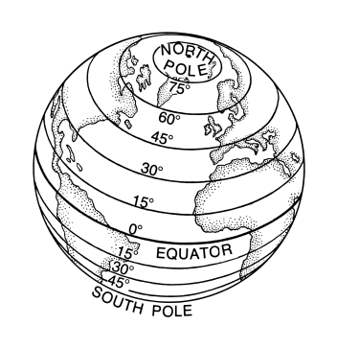
- LATITUDE:
  - Lines extending east and west around the earth and measure the distance north and south of the Equator (0 degrees)
  - Because the Earth is tilted on its axis, the sun heats it unevenly
  - Areas _______________ to the equator get __________ direct sunlight all year
  - Areas _______________ from the equator get _________ direct sunlight

- ALTITUDE:
  - The ________________ the altitude the ___________________ the temperature
  - 150 m rise in altitude = 1 degree drop in temperature

- DISTANCE FROM THE SEA:
  - The _____________ of land heats and cools more ____________ than ________.
  - Large landmasses can vary between temperature __________________.
  - Summer and Winter temperatures on the West Coast are moderated by the __________.

- WIND DIRECTION:
  - Depending on their point of origin, winds can _________ or _________ the temperature.
  - In Canada, _______________ winds (those that usually come from one direction) most often come from the ________, or the north.
  - West Coast communities are unique in Canada with winter temperatures above freezing. They have mildest winter temperatures as a result of warm ______________ winds coming off the ocean.
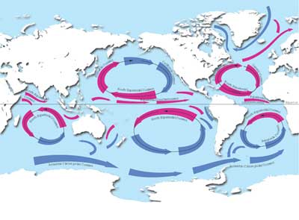
- OCEAN CURRENTS:
  - Affect temperature by warming or cooling the air.
  - Ocean currents can be warm or cool depending on their ____________.
  - Affect temperature of land by warming or heating the air blowing over them.
  - Warm air can hold more ____________ than cold air; this is why West Coast has a mild, ______ climate.

Precipitation: drizzle, showers, heavy rain, hail, fog, or snow they all have an impact on the location they fall.
- The amount of precipitation a location receives depends on its __________________________, and the ______________________________.
- Western Canada experience three types of precipitation:
1.
2.
3.

Question
Which one of the five conditions affecting temperature do you think has the greatest impact on Victoria and why? Explain your reasoning with supporting details. (Minimum 4 sentences)
__________________________________________________________________________________________________________________________________________________________________________________________________________________________________________________________________________________________________________________________________________________________________________________________________________________________________________________________________________________________________________________________________________________________________
______________________________________________________________________________

